**Uptime Monitoring**

* For the overview of the setup  
  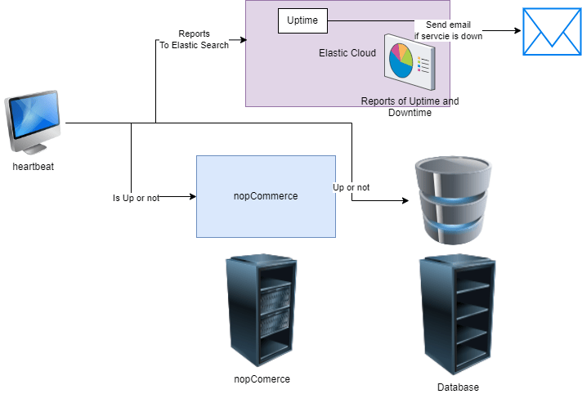
* Lets create a linux machine and
  + install heart beat
  + configure heart beat to send metrics to elastic cloud
* We will be configuring heart beat to check if the
  + apache server is alive  
    bash  
    sudo apt update  
    sudo apt install apache2 -y
* Heart beat installation:
  + <https://www.elastic.co/guide/en/beats/heartbeat/current/heartbeat-installation-configuration.html> for the overview
  + <https://www.elastic.co/guide/en/beats/heartbeat/current/heartbeat-installation-configuration.html#installation> for official docs on installing heart beat and <https://www.elastic.co/guide/en/beats/heartbeat/current/setup-repositories.html#_apt> for apt based installation
* Configuration:
  + All the elastic stack is generally installed and configuration files are stored in similar directories
  + config location: /etc/<prod-name>
  + install location: /usr/share/<prod-name>
* Edit /etc/heartbeat/heartbeat.yml to add cloud id and auth
* What has to be monitored
  + apache server
  + Monitor types: <https://www.elastic.co/guide/en/beats/heartbeat/current/configuration-heartbeat-options.html#monitor-types>

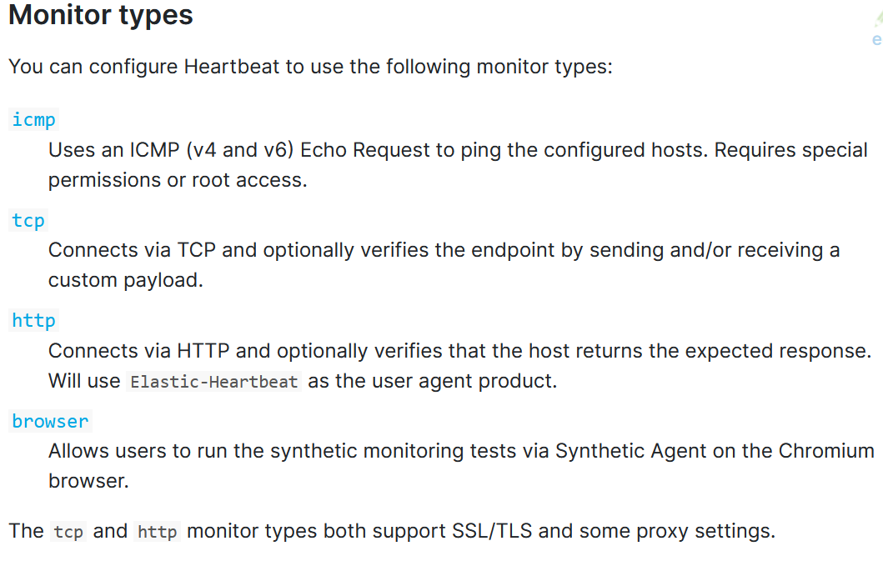

* Configuration  
  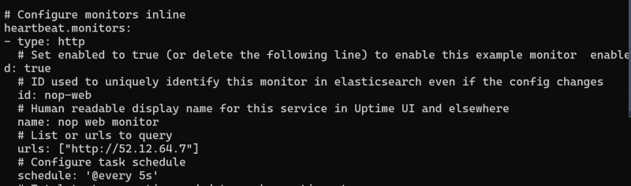
* Start heart beat: [Refer Here](https://www.elastic.co/guide/en/beats/heartbeat/current/heartbeat-installation-configuration.html#start)  
  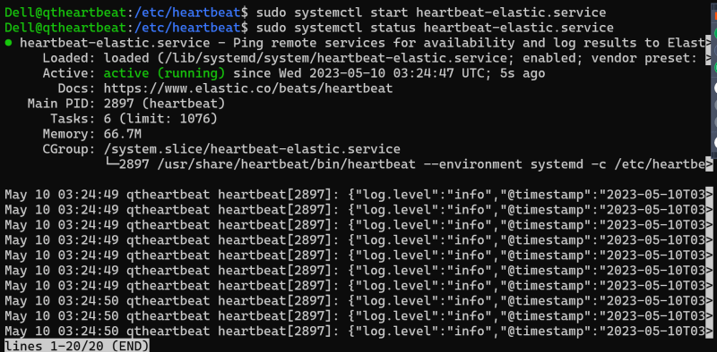
* Now open kibana & navigate to uptime  
  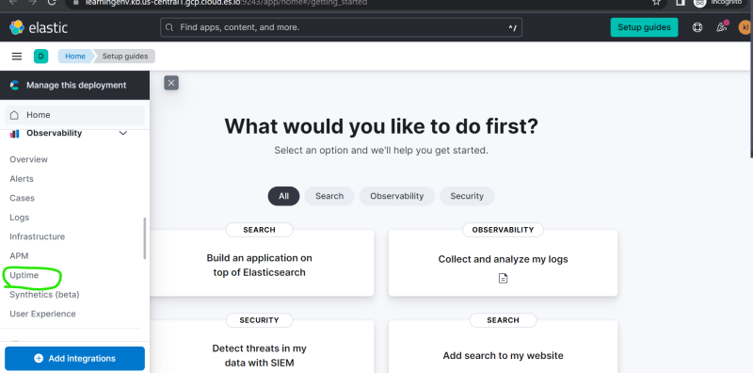  
  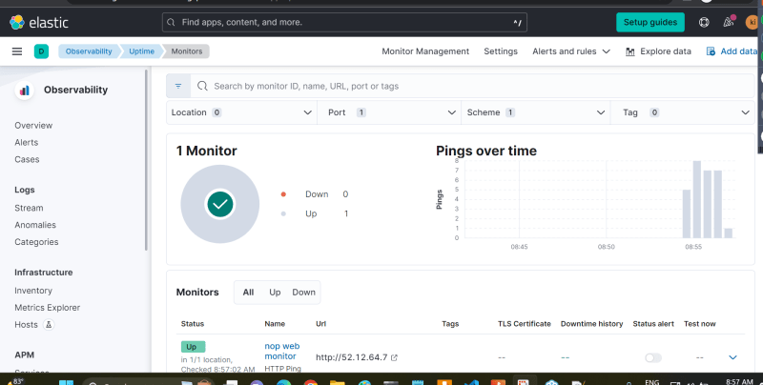
* To view th down status. stop the service and wait for the page to reload  
  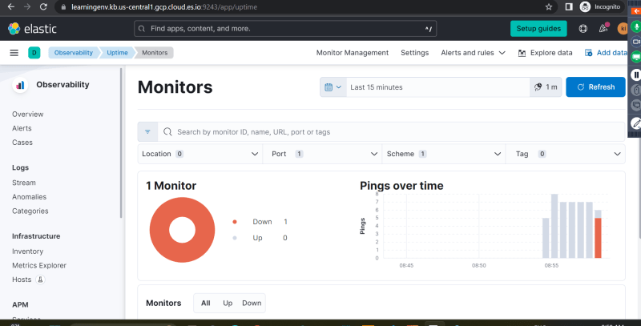
* Lets create an alert to send email about status of server  
  